**Arduino examples**

**LED CONTROL IN TINKERCAD**

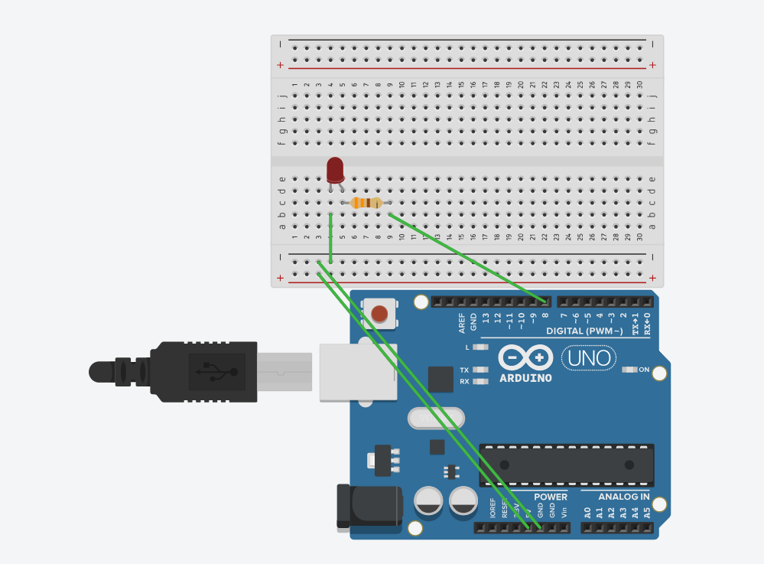

**CODE:**

**void setup()**

**{**

**pinMode(LED_BUILTIN, OUTPUT);**

**}**

**void loop()**

**{**

**digitalWrite(LED_BUILTIN, HIGH);**

**delay(1000); // Wait for 1000 millisecond(s)**

**digitalWrite(LED_BUILTIN, LOW);**

**delay(1000); // Wait for 1000 millisecond(s)**

**}**

**LED CONTROL USING PUSH BUTTON IN TINKERCAD**

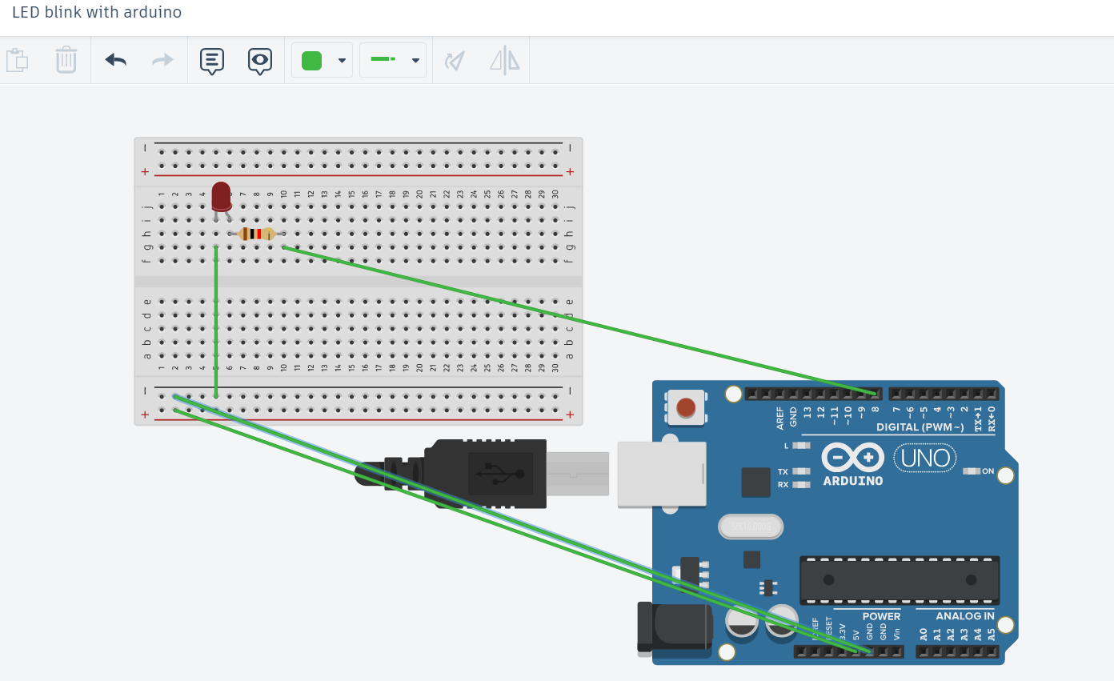

CODE:  
int ledPin=8; //definition digital 8 pins as pin to control the LED

void setup()

{

pinMode(ledPin,OUTPUT); //Set the digital 8 port mode, OUTPUT: Output mode

}

void loop()

{

digitalWrite(ledPin,HIGH); //HIGH is set to about 5V PIN8

delay(1000); //Set the delay time, 1000 = 1S

digitalWrite(ledPin,LOW); //LOW is set to about 5V PIN8

delay(1000); //Set the delay time, 1000 = 1S

}